- Inventory – Dashboard

  - When the order status changes to ‘Accepted’, no tools appear on the Inventory page.
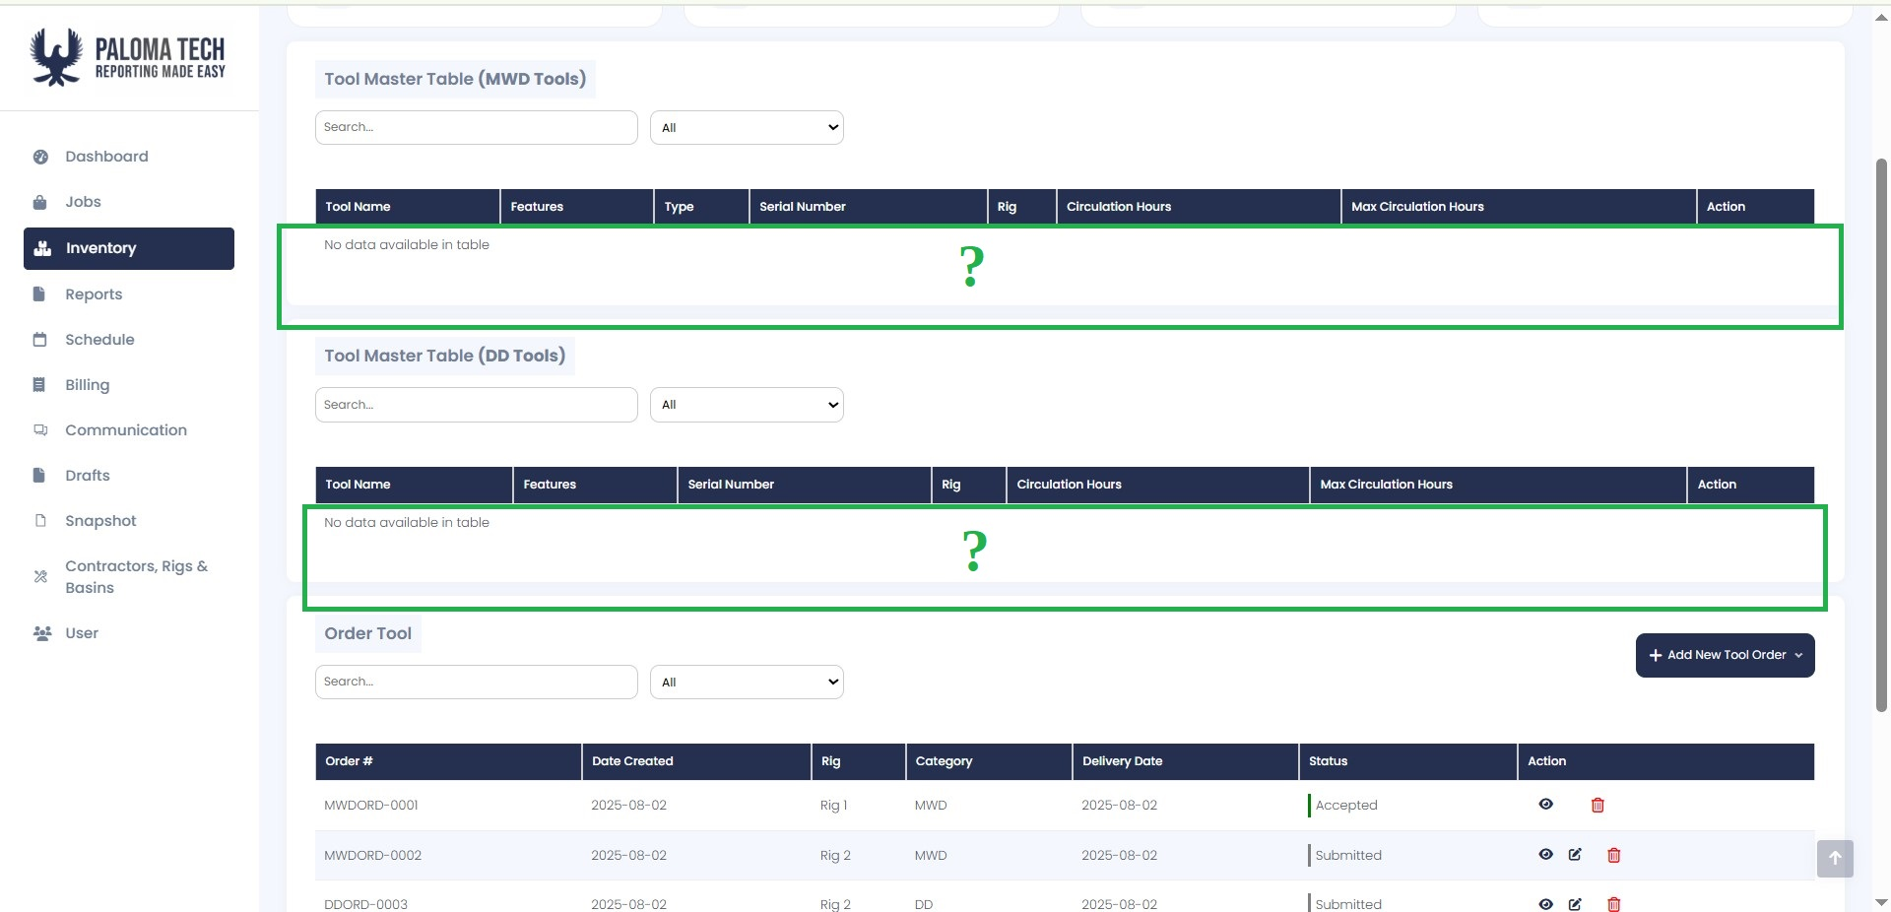

- DD Tools

  - The feature descriptions in the ‘Features’ column should match those in the tool selection screen — including capitalization, parentheses, and other formatting.

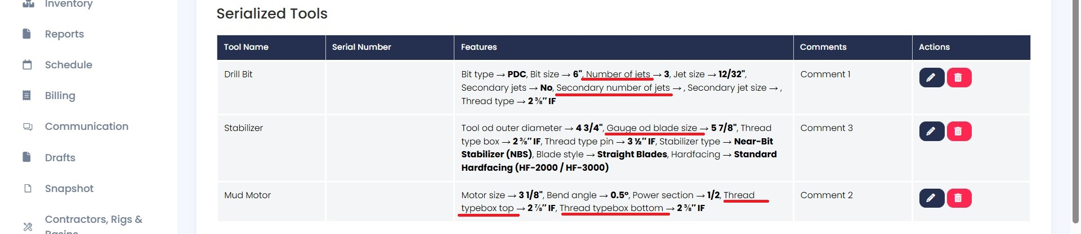

  - Add a ‘Back’ button, as in all other screens

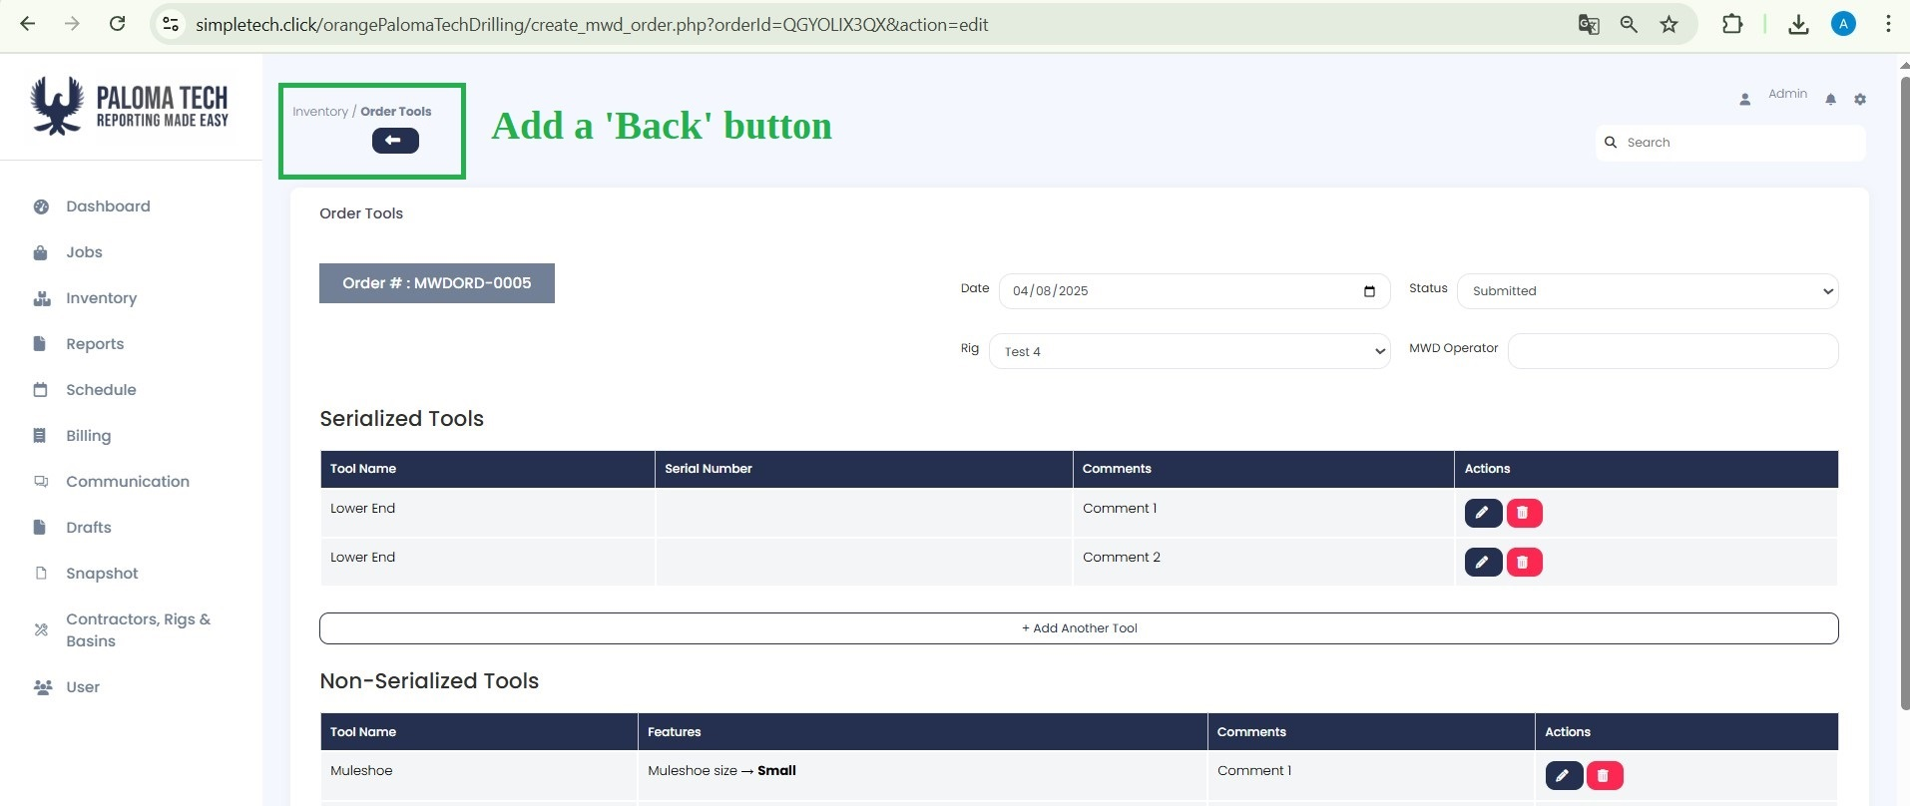

- DD Serial Numbers

  - As it is now, no values can be entered in the S/N fields after submitting a tool order

As it was mentioned previously when the MWD or DD submits the order for the Shop, they'd write down what components they need, leave the S/N fields empty(for the DD Tools), and submit it. (At that point, the order status would be set to 'Submitted'.)

Then the Shop would see the order, find the components, fill in the S/Ns in the same form, and once they send it out, they'd change the status from 'Submitted' to 'In Transit'

The order should not be editable after submission. The only fields that remain editable are the S/N and the ‘Status’ (by the Shop). (With this in mind, the S/N field should NOT be editable by the user placing the order — only by the shop vendor but or now, they can remain as is for testing and review purposes). Before submission, a prominent pop-up window should inform the user: ‘Please review the order carefully before submission!
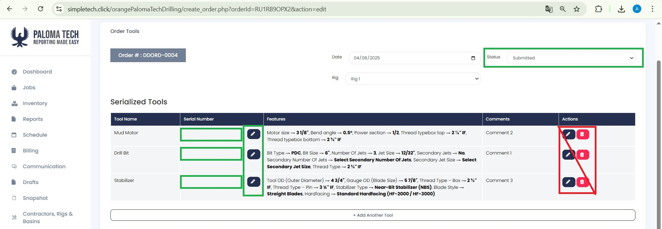

After the Shop fulfills the order and changes the status to ‘In Transition’, no further edits can be made — except when the MWD user receives the goods, checks them, and changes the status to ‘Accepted’.

In that sense, the ‘Edit’ and ‘Delete’ options for orders in the Inventory dashboard should be removed. However, for now, they can remain as is for testing and review purposes — but they must be removed in the final version.

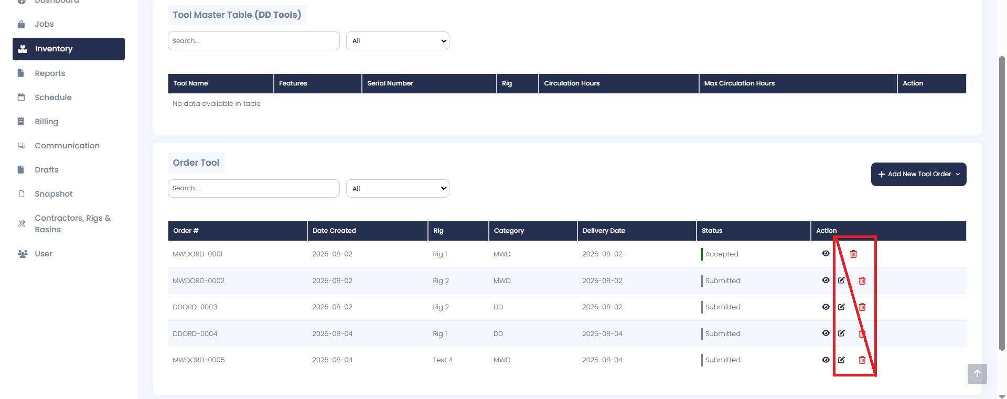

Considering all of the above, in the final version of the software, the Shop Owner should have separate credentials, allowing them to edit ONLY the S/N and the order status — without being able to modify ANYTHING else.

- Tool OD (Outer Diameter), Tool ID (Inner Diameter), Length (ft)

  - The name should be ‘Length (ft) with lower f and with a parenthesis.

- ‘Other’ from drop-down → double entries in features column

  - When the ‘Other’ option is selected from a drop-down menu, the title of the new field should be labeled as ‘Enter …’ instead of ‘Custom …’ — for example, ‘Enter Bit Type’ rather than ‘Custom Bit Type’. However, in the features list, it should still appear simply as ‘Bit Type → “xxx”’, even if the value was entered manually.

Now if I select ‘Other’ for a feature, two different entries appear in the ‘Features’ column.

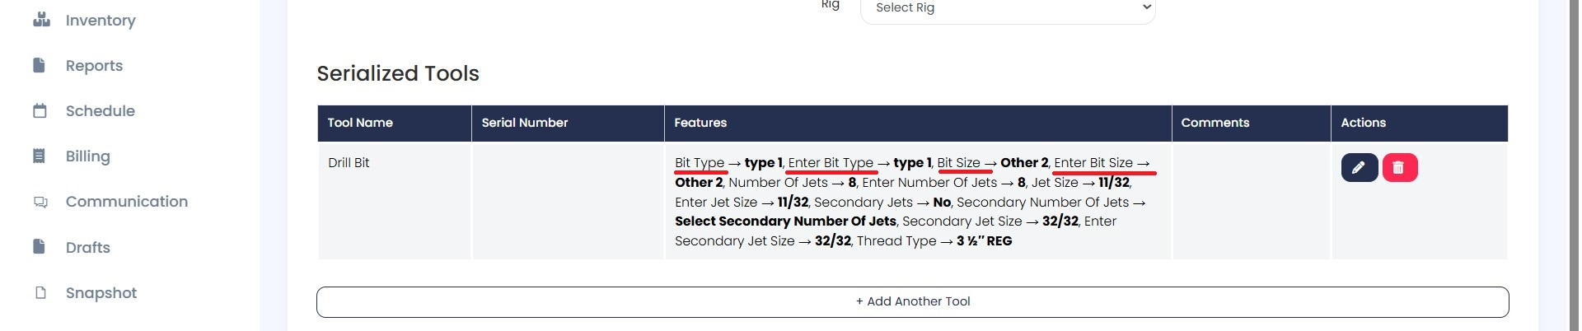

- ‘Drill Bit’

  - The ‘Secondary Jet Size’ field should only appear when ‘Yes’ is selected in the ‘Secondary Jets’ drop-down

- ‘Pony Sub’

  - The ‘ft’ in ‘Legnth ft’ should be in parenthesis and with lowercase f→ Length (ft)

- ‘UBHO Sub’

  - The ‘ft’ in ‘Legnth ft’ should be in parenthesis and with lowercase f→ Length (ft)

- ‘Non-Magnetic Drill Collar’

  - The ‘ft’ in ‘Legnth ft’ should be in parenthesis and with lowercase f→ Length (ft)

- ‘X-O Sub’

  - The ‘ft’ in ‘Legnth ft’ should be in parenthesis and with lowercase f→ Length (ft)

- ‘Shock Sub’

  - The ‘ft’ in ‘Legnth ft’ should be in parenthesis and with lowercase f→ Length (ft)

- ‘Agitator’

  - The ‘ft’ in ‘Legnth ft’ should be in parenthesis and with lowercase f→ Length (ft)

- Drill Pipe

  - The ‘ft’ in ‘Legnth ft’ should be in parenthesis and with lowercase f→ Length (ft)

- Heavy Weight Drill Pipe (HWDP)

  - The ‘ft’ in ‘Legnth ft’ should be in parenthesis and with lowercase f→ Length (ft)

- ‘Stabilizer’

  - The ‘Stabilizer’ tool appears twice in the tool list.

- ‘Heavy Weight Drill Pipe (HWDP)’

  - The ‘ft’ in ‘Legnth ft’ should be in parenthesis and with lowercase f→ Length (ft)

- ‘Drill Collar’

  - The ‘ft’ in ‘Legnth ft’ should be in parenthesis and with lowercase f→ Length (ft)

  - ‘Material’ → Other : The new field that appears should be titled ‘Other Material’
There seems to be some misunderstanding here. The field is named ‘Material Type’ and it has a drop-down list. The clarification above refers to the selection of ‘Other’ from the list, and the name of the new field that will appear for manual input.

  - ‘Color Type’ → Other : The new field that appears should be titled ‘Other Color Type’
Same as the above
- MWD Tools – Tool Selection

  - The ‘Name’, ‘S/N’, and ‘Comments’ value fields for both Serialized and Non-Serialized Tools should also be aligned on the right

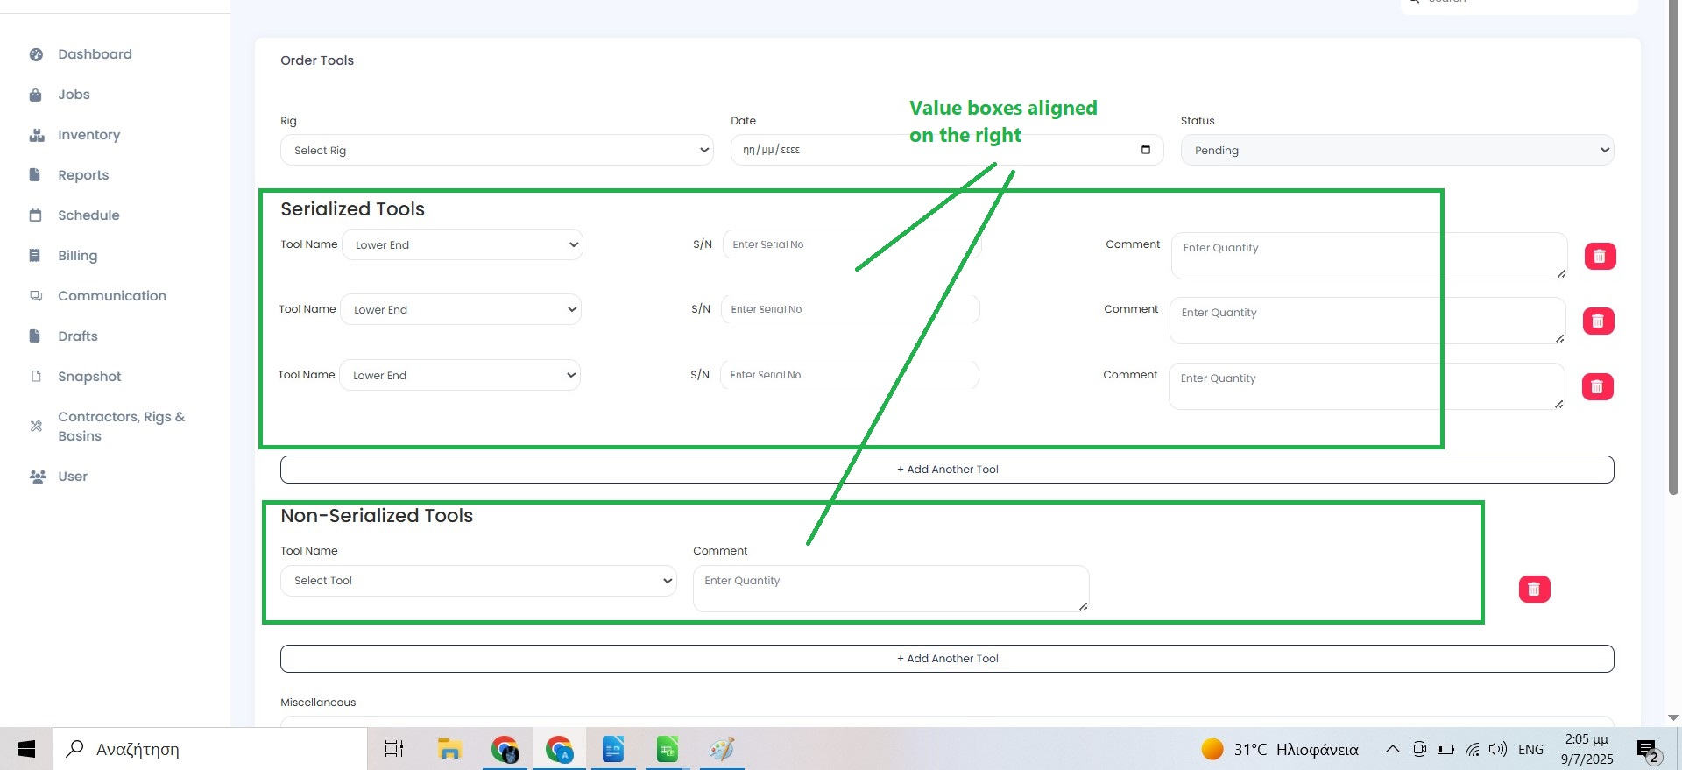

- MWD Tools – Non-Serialized

  - Remove the ‘List’ text box altogether. The ‘Comment’ text box should be enough.

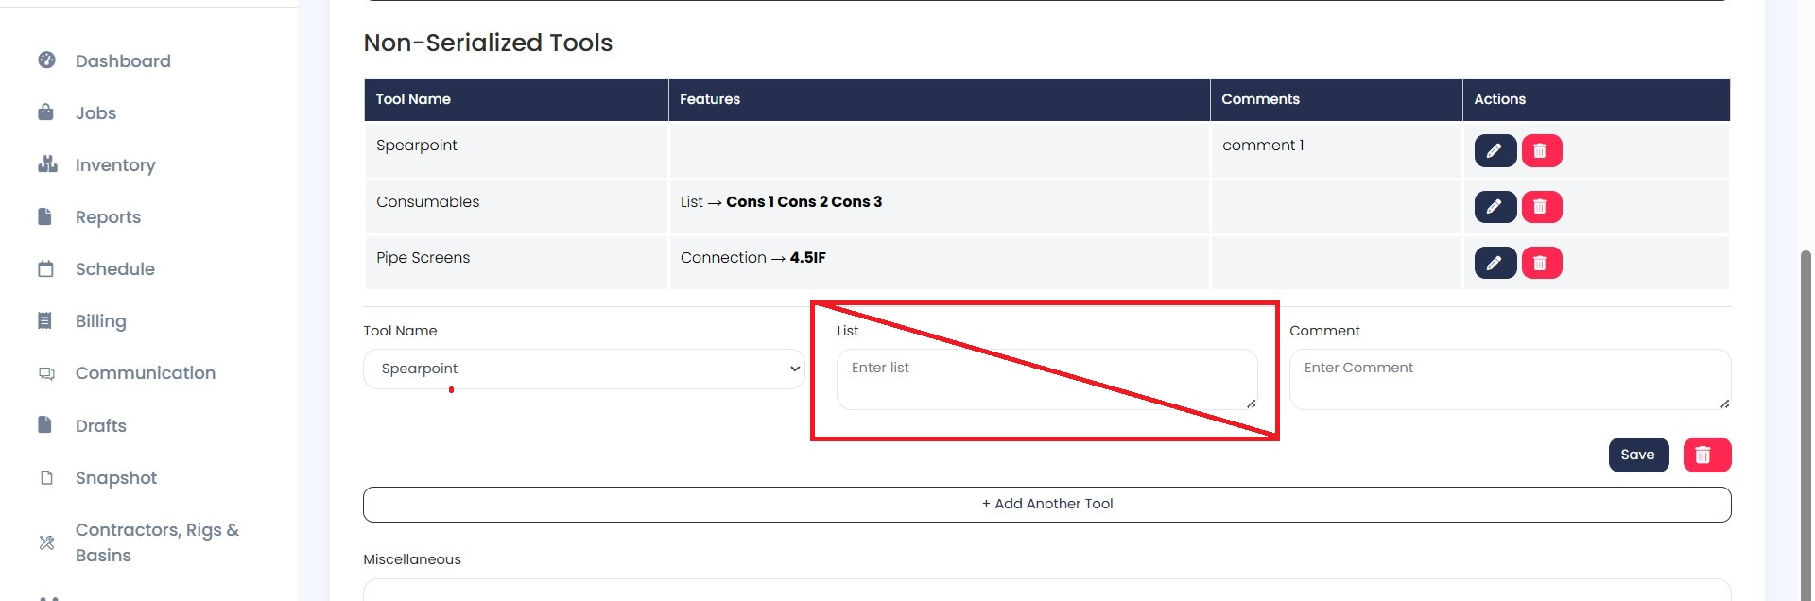

  - J

